SIMATS ENGINEERING
ASSESSMENT TOOL 2

COURSE NAME: Database Management Systems
COURSE CODE: CSA05

COURSE OUTCOME COVERED

CO2: Apply the relational model, relational algebra, SQL query structures, and views to solve database querying and data manipulation problems. (BL3, BL6)

Activity Tool : Scenario-Based Task (Medium)
Assessment Tool Weightage: 20%

QUESTIONS
Q.No | Question | Bloom's Level
1 | A university stores student and course data in a single table. Analyze the structure and identify normalization issues, then redesign it up to 3NF | . BL4 – Analyze
2 | A company database contains employee and department details. Design appropriate SQL queries to retrieve employees working in multiple departments and justify your approach | . BL6 – Create
3 | Given a relation with multiple functional dependencies, determine the candidate keys and check whether the relation satisfies BCNF. If not, decompose it. | BL5 – Evaluate
4 | A banking system requires secure data access. Design views and constraints to ensure data security and integrity for different types of users. | BL6 – Create
5 | A sales database contains redundant data leading to anomalies. Analyze the schema and apply normalization up to 3NF or BCNF to eliminate redundancy. | BL4 – Analyze
6 | Given a dataset of customers and orders, write SQL queries using joins and subqueries to retrieve meaningful information such as frequent customers. | BL3 – Apply
7 | A relation contains multi-valued dependencies. Analyze the structure and decompose it into 4NF, explaining the reasoning. | BL4 – Analyze
8 | A database designer used improper constraints, leading to inconsistent data. Evaluate the schema and suggest appropriate integrity constraints. | BL5 – Evaluate
9 | For a given relational schema, analyze the presence of join dependencies and decompose it into 5NF to remove redundancy. | BL6 – Create
10 | A system uses inefficient SQL queries for data retrieval. Analyze the queries and optimize them using joins, indexing concepts, or query restructuring. | BL5 – Evaluate

Code of Conduct:

I DEEPTHI KORRAPATI(192572012) (Name / Reg No) certify that this submission is my original work and that I have adhered to the guidelines specified for this assessment.
I understand that any violation of academic integrity rules will result in disciplinary action.

Signature of the student:

RUBRICS FOR CALCULATION:

Criteria | Level 4 (Exemplary) | Level 3 (Proficient) | Level 2 (Developing) | Level 1 (Beginning)
Understanding of Scenario | Demonstrates clear and complete understanding of the scenario and context | Shows good understanding with minor gaps | Partial understanding; misses key aspects | Misinterprets or fails to understand the scenario
Identification of Key Issues | Accurately identifies all relevant issues and factors involved | Identifies most key issues with minor omissions | Identifies limited issues; some irrelevant points | Unable to identify key issues
Application of Concepts | Applies appropriate concepts effectively to address the scenario | Applies concepts with minor errors | Limited or partially correct application | Unable to apply relevant concepts
Decision Making | Makes well-reasoned, logical decisions with strong rationale | Makes reasonable decisions with some justification | Makes weak decisions with limited justification | No clear decisions made or rationale provided
Clarity of Response | Response is clear, structured, and logically presented | Generally clear with minor issues | Somewhat unclear or poorly structured | Disorganized and difficult to understand
Q1. A University Stores Student and Course Data in a Single Table. Analyze the Structure, Identify Normalization Issues, and Redesign it up to 3NF.

1. Introduction
A database stores information in the form of tables. If all data is stored in a single table, it often leads to data redundancy, inconsistency, and data anomalies. Normalization is a database design technique used to organize data efficiently by dividing large tables into smaller related tables.
The goal of normalization is to eliminate duplicate data and maintain data integrity.

2. Definition of Normalization
Normalization is the process of organizing data in a relational database to reduce redundancy and dependency by dividing tables into smaller tables and establishing relationships.

3. Objectives of Normalization
- Eliminate duplicate data.
- Improve data consistency.
- Reduce storage space.
- Prevent insertion, update, and deletion anomalies.
- Improve database performance.
- Maintain data integrity.

4. Existing University Table
StudentID | StudentName | CourseID | CourseName | FacultyID | FacultyName
101 | Rahul | C101 | DBMS | F01 | Dr. Rao
101 | Rahul | C102 | Java | F02 | Dr. Kumar
102 | Priya | C101 | DBMS | F01 | Dr. Rao
103 | Asha | C103 | CN | F03 | Dr. Sharma

5. Problems in the Table
Data Redundancy
Student and faculty details are repeated.
Example:
Rahul appears multiple times.
Dr. Rao appears multiple times.

Update Anomaly
If Dr. Rao changes his name, every record must be updated.
Missing one record causes inconsistency.

Insertion Anomaly
A new course cannot be inserted until at least one student enrolls.

Deletion Anomaly
If the last student leaves a course, course information is lost.

6. Functional Dependencies
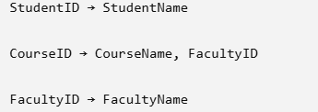

7. First Normal Form (1NF)
Rule
- Atomic values only.
- No repeating groups.
The table already satisfies 1NF because every column contains single values.

8. Second Normal Form (2NF)
Remove partial dependencies.
Student Table
StudentID | StudentName
101 | Rahul
102 | Priya
103 | Asha

Course Table
CourseID | CourseName | FacultyID
C101 | DBMS | F01
C102 | Java | F02
C103 | CN | F03

Enrollment Table
StudentID | CourseID
101 | C101
101 | C102
102 | C101
103 | C103

9. Third Normal Form (3NF)
Remove transitive dependency.
Faculty Table
FacultyID | FacultyName
F01 | Dr. Rao
F02 | Dr. Kumar
F03 | Dr. Sharma

Final 3NF Design
Student
|StudentID|StudentName|
Course
|CourseID|CourseName|FacultyID|
Faculty
|FacultyID|FacultyName|
Enrollment
|StudentID|CourseID|

10. SQL Statements
Student
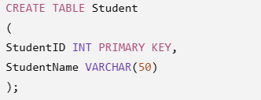

Faculty
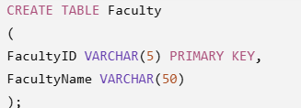

Course
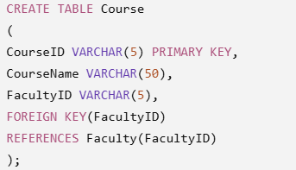

Enrollment
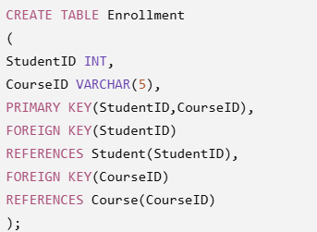

11. Relationship Diagram
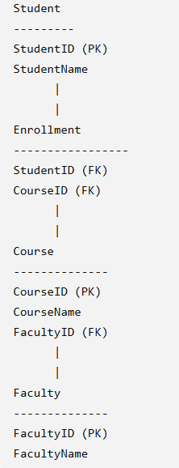

12. Advantages of 3NF
- Eliminates redundancy.
- Prevents anomalies.
- Improves consistency.
- Faster updates.
- Better maintenance.
- Efficient storage.
- Easier query execution.

13. Applications
- University Management System
- College ERP
- Online Learning Platforms
- School Databases
- Student Information Systems

15. Conclusion
Normalization up to 3NF creates an efficient university database by separating students, courses, faculties, and enrollments into different tables. This reduces duplication, prevents anomalies, and improves database performance and maintainability.

Q2. A Company Database Contains Employee and Department Details. Design Appropriate SQL Queries to Retrieve Employees Working in Multiple Departments and Justify Your Approach.

1. Introduction
In many organizations, employees may work in more than one department. Such relationships are represented using a separate mapping table between employees and departments. SQL queries using JOIN, GROUP BY, and HAVING help retrieve employees assigned to multiple departments.

2. Database Schema
Employee Table
EmpID | EmpName
101 | Rahul
102 | Priya
103 | Asha

Department Table
DeptID | DeptName
D01 | HR
D02 | IT
D03 | Finance

EmployeeDepartment Table
EmpID | DeptID
101 | D01
101 | D02
102 | D01
103 | D02
103 | D03

3. SQL Table Creation

Employee
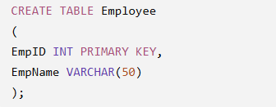

Department
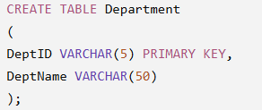

EmployeeDepartment
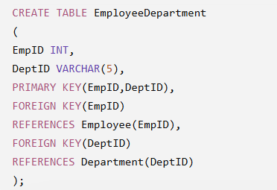

SQL Query to Find Employees Working in Multiple Departments
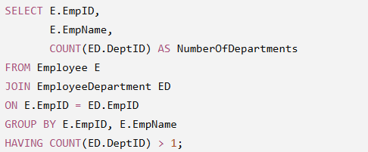

Explanation
- JOIN combines employee and department mapping tables.
- GROUP BY groups records by employee.
- COUNT() counts departments assigned to each employee.
- HAVING filters employees working in more than one department.

6. Expected Output
EmpID | EmpName | NumberOfDepartments
101 | Rahul | 2
103 | Asha | 2

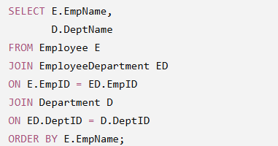

8. Output
Employee | Department
Rahul | HR
Rahul | IT
Priya | HR
Asha | IT
Asha | Finance

9. Justification of the Approach
- JOIN retrieves related data from multiple tables.
- GROUP BY organizes records employee-wise.
- COUNT() determines the number of departments.
- HAVING filters grouped results after aggregation.
- The design avoids duplicate employee or department information and follows database normalization principles.

10. Advantages
- Efficient retrieval of employee information.
- Eliminates data redundancy.
- Supports many-to-many relationships.
- Easy to maintain.
- Improves query performance.

11. Applications
- Human Resource Management Systems
- Payroll Systems
- University Faculty Allocation
- Hospital Staff Management
- Project Team Allocation
- Government Employee Management

13. Conclusion
Using JOIN, GROUP BY, and HAVING, employees working in multiple departments can be identified accurately and efficiently.

Q3. Given a Relation with Multiple Functional Dependencies, Determine the Candidate Keys and Check Whether the Relation Satisfies BCNF. If Not, Decompose It.

1. Introduction
In relational database design, Functional Dependencies (FDs) define relationships between attributes. They help identify candidate keys and determine whether a relation satisfies Boyce-Codd Normal Form (BCNF). BCNF is a stronger version of Third Normal Form (3NF) and removes redundancy caused by improper functional dependencies.

2. Functional Dependency (FD)
A Functional Dependency is a relationship where one attribute uniquely determines another.
Notation:
A → B
This means the value of A uniquely determines the value of B.
Example:
StudentID → StudentName

3. Candidate Key
A Candidate Key is the minimum set of attributes that uniquely identifies each tuple (row) in a relation.
Properties:
- Unique
- Minimal
- No unnecessary attributes

4. BCNF (Boyce-Codd Normal Form)
A relation is in BCNF if:
For every non-trivial functional dependency X → Y, X must be a super key.

5. Given Relation
Relation
R(StudentID, CourseID, FacultyID, FacultyName)
Functional Dependencies
StudentID, CourseID → FacultyID

FacultyID → FacultyName

6. Find Candidate Key
Closure of:
(StudentID, CourseID)+
Using FD1
StudentID, CourseID → FacultyID
Using FD2
FacultyID → FacultyName
Closure becomes
(StudentID, CourseID)+

=

StudentID

CourseID

FacultyID

FacultyName
Since all attributes are obtained,
Candidate Key
(StudentID, CourseID)

7. Check BCNF
FD1
StudentID, CourseID → FacultyID
LHS is Candidate Key
✓ Satisfies BCNF

FD2
FacultyID → FacultyName
FacultyID is not a Candidate Key.
Therefore,
BCNF is violated.

8. BCNF Decomposition
Split relation into:
Faculty
FacultyID | FacultyName
F01 | Dr. Rao
F02 | Dr. Kumar

StudentCourse
StudentID | CourseID | FacultyID
101 | C101 | F01
101 | C102 | F02
102 | C101 | F01

9. SQL Statements
Faculty Table
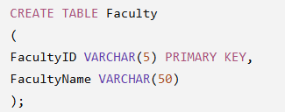

StudentCourse Table

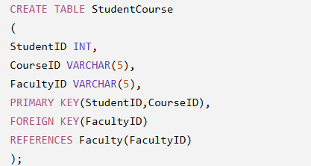

10. Advantages of BCNF
- Removes redundancy.
- Eliminates update anomalies.
- Improves consistency.
- Better database design.
- Efficient storage.
11. Applications
- Banking Systems
- University Databases
- Airline Reservation
- Hospital Management
- ERP Systems

13. Conclusion
BCNF improves database design by ensuring that every determinant is a candidate key or super key. Decomposing relations into BCNF reduces redundancy, maintains consistency, and prevents update anomalies.

Q4. A Banking System Requires Secure Data Access. Design Views and Constraints to Ensure Data Security and Integrity for Different Types of Users.

1. Introduction
A banking database stores highly sensitive information such as customer details, account balances, and transaction records. To protect this data, databases use Views and Integrity Constraints. Views restrict access to selected columns or rows, while constraints ensure only valid data is stored.

2. What is a View?
A View is a virtual table created using a SQL query. It does not store data physically but displays data from one or more tables.
Syntax
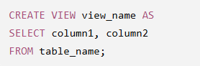

3. What are Integrity Constraints?
Integrity constraints are rules that maintain the accuracy and consistency of data.
Types:
- PRIMARY KEY
- FOREIGN KEY
- NOT NULL
- UNIQUE
- CHECK
- DEFAULT

4. Banking Database Schema
Customer Table
CustomerID | CustomerName | Phone
101 | Rahul | 9876543210
102 | Priya | 9876501234
Account Table
AccountNo | CustomerID | Balance | AccountType
5001 | 101 | 50000 | Savings
5002 | 102 | 75000 | Current

5. Create Tables with Constraints
Customer Table
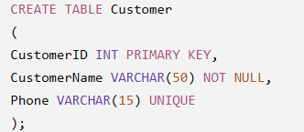

Account Table

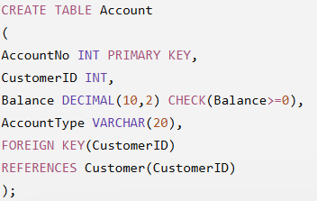

6. Create Views
Customer View
Employees can see customer names but not balances.
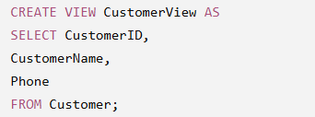

Manager View
Managers can access complete account details.
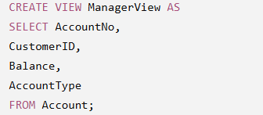

Auditor View
Auditors can view account information without modifying it.
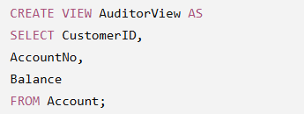

7. Security Benefits
- Hides confidential information.
- Restricts unauthorized access.
- Provides role-based access.
- Simplifies report generation.

8. Integrity Constraints Used
Constraint | Purpose
PRIMARY KEY | Unique account/customer
FOREIGN KEY | Maintains relationships
NOT NULL | Mandatory values
UNIQUE | Prevents duplicate phone numbers
CHECK | Balance cannot be negative

9. Applications
- Banking Systems
- ATM Software
- Online Banking
- Credit Card Systems
- Insurance Databases

10. Advantages
- Improved security.
- Data consistency.
- Prevents invalid entries.
- Easy maintenance.
- Supports multiple user roles.

12. Conclusion
Views and integrity constraints are essential for secure and reliable banking databases. Views provide controlled access for different users, while constraints maintain data accuracy and integrity. Together, they ensure confidentiality, consistency, and secure database operations.

Q5. A Sales Database Contains Redundant Data Leading to Anomalies. Analyze the Schema and Apply Normalization up to 3NF or BCNF to Eliminate Redundancy.

1. Introduction
A Sales Database stores information about customers, products, orders, and sales representatives. If all information is stored in a single table, it leads to data redundancy, update anomalies, insertion anomalies, and deletion anomalies. Normalization organizes the data into multiple related tables to eliminate redundancy and improve database efficiency.

2. Definition of Normalization
Normalization is the process of organizing data into multiple related tables to reduce redundancy and improve data integrity.

3. Objectives of Normalization
- Eliminate duplicate data.
- Improve consistency.
- Reduce storage space.
- Prevent anomalies.
- Improve database performance.
- Simplify maintenance.

4. Existing Sales Table
OrderID | CustomerID | CustomerName | ProductID | ProductName | SalesPersonID | SalesPersonName
1001 | C101 | Rahul | P01 | Laptop | S01 | Ramesh
1002 | C101 | Rahul | P02 | Mouse | S01 | Ramesh
1003 | C102 | Priya | P01 | Laptop | S02 | Suresh

5. Problems in the Schema
Data Redundancy
- Customer names are repeated.
- Product names are repeated.
- Salesperson names are repeated.
Update Anomaly
Changing the salesperson's name requires updating multiple rows.
Insertion Anomaly
A new product cannot be inserted until an order is placed.
Deletion Anomaly
Deleting the last order for a product may remove product information.

6. Functional Dependencies
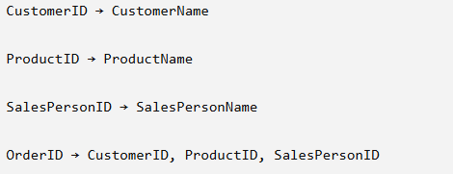

7. First Normal Form (1NF)
The table satisfies 1NF because all values are atomic.

8. Second Normal Form (2NF)
Separate customer, product, and salesperson details.
Customer Table
CustomerID | CustomerName
C101 | Rahul
C102 | Priya
Product Table
ProductID | ProductName
P01 | Laptop
P02 | Mouse
SalesPerson Table
SalesPersonID | SalesPersonName
S01 | Ramesh
S02 | Suresh
Orders Table
OrderID | CustomerID | ProductID | SalesPersonID
1001 | C101 | P01 | S01
1002 | C101 | P02 | S01
1003 | C102 | P01 | S02

9. Third Normal Form (3NF)
The above decomposition satisfies 3NF because every non-key attribute depends only on the primary key.

10. SQL Statements
Customer
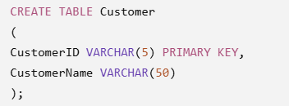

Product
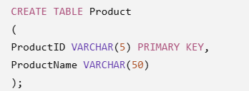

SalesPerson
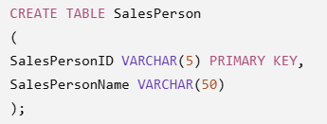

Orders
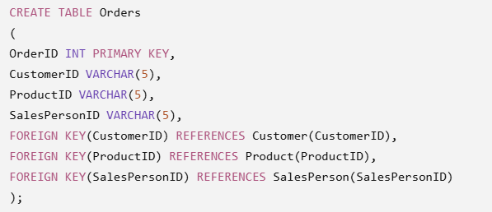

11. Advantages of 3NF/BCNF
- Eliminates redundancy.
- Prevents anomalies.
- Improves consistency.
- Saves storage.
- Easier maintenance.
- Faster updates.

12. Applications
- Sales Management
- Inventory Systems
- Retail Stores
- E-commerce
- Billing Systems

14. Conclusion
Normalization up to 3NF/BCNF removes redundant customer, product, and salesperson information, resulting in a well-structured sales database that is efficient, consistent, and easy to maintain.
Q6. Given a Dataset of Customers and Orders, Write SQL Queries Using Joins and Subqueries to Retrieve Meaningful Information Such as Frequent Customers. (30 Marks)
1. Introduction
Businesses store customer and order details in separate tables. Joins combine related tables, while subqueries help answer complex questions such as identifying frequent customers, customers with the highest purchases, and customers who have never placed an order.

2. Database Schema
Customer Table
CustomerID | CustomerName | City
101 | Rahul | Hyderabad
102 | Priya | Chennai
103 | Asha | Bangalore
Orders Table
OrderID | CustomerID | Amount
5001 | 101 | 12000
5002 | 101 | 9000
5003 | 102 | 15000
5004 | 101 | 7000
3.SQL Table Creation
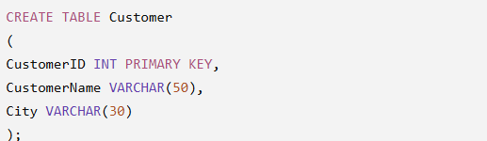
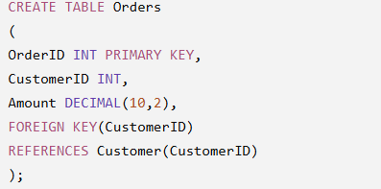

4. Query to Display Customer Orders
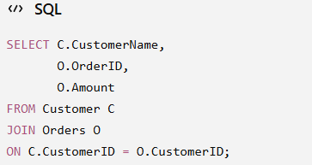

Output
CustomerName | OrderID | Amount
Rahul | 5001 | 12000
Rahul | 5002 | 9000
Priya | 5003 | 15000
Rahul | 5004 | 7000

5. Query to Find Frequent Customers
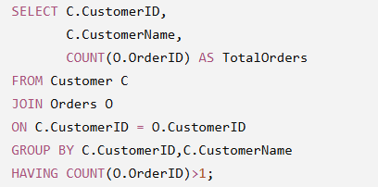

Output
CustomerID | CustomerName | TotalOrders
101 | Rahul | 3

6. Subquery to Find Customer with Highest Total Purchase
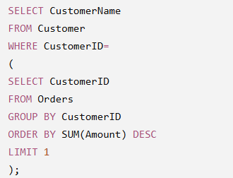

Output
CustomerName
Rahul

7. Subquery to Find Customers Who Never Placed Orders

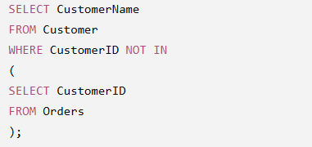

8. Explanation
- JOIN combines customer and order information.
- GROUP BY groups orders by customer.
- COUNT() counts the number of orders.
- HAVING filters customers based on the number of orders.
- Subqueries solve complex retrieval problems.

9. Advantages
- Retrieves related information efficiently.
- Supports business analysis.
- Helps identify valuable customers.
- Reduces manual calculations.
- Improves reporting.

10. Applications
- Customer Relationship Management (CRM)
- Online Shopping
- Banking Systems
- Hospital Billing
- Sales Analytics
- Retail Management

12. Conclusion
Joins and subqueries are powerful SQL techniques for retrieving meaningful information from related tables. They enable businesses to identify frequent customers, analyze purchase patterns, generate reports, and support better decision-making.

Q7. A Relation Contains Multi-Valued Dependencies. Analyze the Structure and Decompose it into 4NF, Explaining the Reasoning.

1. Introduction
In relational databases, a table may contain multi-valued dependencies (MVDs), where one attribute determines multiple independent values of another attribute. Such tables contain unnecessary repetition, leading to redundancy and anomalies.
Fourth Normal Form (4NF) removes these multi-valued dependencies by decomposing the relation into smaller tables.

2. Definition of Multi-Valued Dependency (MVD)
A Multi-Valued Dependency (MVD) exists when one attribute determines multiple independent values of another attribute.
Notation
A →→ B
This means one value of A is associated with multiple values of B independently.

3. Definition of Fourth Normal Form (4NF)
A relation is in Fourth Normal Form (4NF) if:
- It is already in BCNF.
- It contains no non-trivial Multi-Valued Dependencies.

4. Example Relation
StudentSkillsLanguages
StudentID | Skill | Language
101 | Java | English
101 | Java | Hindi
101 | Python | English
101 | Python | Hindi
102 | C++ | English
102 | C++ | Telugu

5. Multi-Valued Dependencies
StudentID →→ Skill

StudentID →→ Language
Skills and Languages are independent.

6. Problems
Data Redundancy
Java repeats twice.
Python repeats twice.
Languages repeat multiple times.

Update Anomaly
Changing a language requires updating multiple rows.

Insertion Anomaly
Cannot insert a new language unless a skill is also inserted.

Deletion Anomaly
Deleting one skill may accidentally remove language information.

7. Decomposition into 4NF
StudentSkill Table
StudentID | Skill
101 | Java
101 | Python
102 | C++

StudentLanguage Table
StudentID | Language
101 | English
101 | Hindi
102 | English
102 | Telugu

8. SQL Statements
StudentSkill
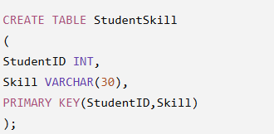

StudentLanguage
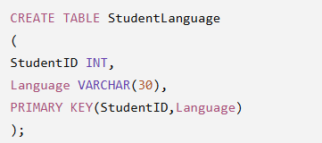

9. Advantages of 4NF
- Eliminates multi-valued dependencies.
- Removes redundant data.
- Prevents anomalies.
- Improves consistency.
- Simplifies updates.

10. Applications
- Student Information Systems
- Employee Skills Database
- Online Learning Platforms
- HR Systems
- Hospital Staff Records

12. Conclusion
Fourth Normal Form removes multi-valued dependencies by separating independent data into different tables. This reduces redundancy, improves consistency, and creates a more efficient database design.

Q8. A Database Designer Used Improper Constraints, Leading to Inconsistent Data. Evaluate the Schema and Suggest Appropriate Integrity Constraints.

1. Introduction
Integrity constraints are rules that ensure only valid and consistent data is stored in a database. If constraints are missing or improperly defined, the database may contain duplicate records, invalid values, and broken relationships.
Applying suitable constraints ensures reliable database operations.

2. Definition of Integrity Constraints
Integrity Constraints are rules enforced by the DBMS to maintain the accuracy and consistency of data.

3. Types of Integrity Constraints
- Primary Key
- Foreign Key
- NOT NULL
- UNIQUE
- CHECK
- DEFAULT

4. Improper Schema
Student Table
StudentID | StudentName | Email | Age | DepartmentID
101 | Rahul | rahul@gmail.com | 20 | D01
101 | Priya | rahul@gmail.com | 17 | D05
NULL | Asha | asha@gmail.com | 22 | D01

5. Problems
Duplicate StudentID
Violates Primary Key.

NULL StudentID
Primary Key cannot be NULL.

Duplicate Email
Violates UNIQUE constraint.

Invalid Age
Suppose minimum age is 18.
Age 17 violates CHECK constraint.

Invalid Department
Department D05 does not exist.
Violates Foreign Key constraint.

6. Correct Schema
Department Table
DepartmentID | DepartmentName
D01 | CSE
D02 | ECE
Student Table
StudentID | StudentName | Email | Age | DepartmentID
101 | Rahul | rahul@gmail.com | 20 | D01
102 | Priya | priya@gmail.com | 21 | D02
103 | Asha | asha@gmail.com | 22 | D01

7. SQL Statements
Department
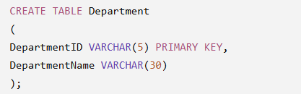

Student
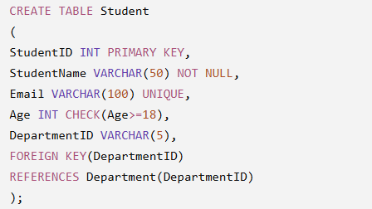

8. Explanation of Constraints
PRIMARY KEY
Uniquely identifies every student.
NOT NULL
Ensures StudentName cannot be empty.
UNIQUE
Prevents duplicate email addresses.
CHECK
Ensures age is at least 18.
FOREIGN KEY
Maintains valid department references.

9. Benefits of Integrity Constraints
- Prevent invalid data.
- Ensure consistency.
- Eliminate duplicate records.
- Maintain relationships.
- Improve database security.
- Reduce data-entry errors.

10. Applications
- Banking Systems
- University Databases
- Hospital Management
- Library Systems
- Airline Reservation
- E-commerce

12. Conclusion
Integrity constraints play a vital role in maintaining database accuracy and reliability. By applying PRIMARY KEY, FOREIGN KEY, NOT NULL, UNIQUE, and CHECK constraints, inconsistent and invalid data can be prevented. Proper use of constraints improves database security, consistency, and overall performance.

Q9. For a Given Relational Schema, Analyze the Presence of Join Dependencies and Decompose it into 5NF to Remove Redundancy.

1. Introduction
In relational database design, even after normalization up to Fourth Normal Form (4NF), some redundancy may still exist due to Join Dependencies (JD). Fifth Normal Form (5NF), also called Project-Join Normal Form (PJNF), eliminates this redundancy by decomposing relations into smaller tables without losing information.
5NF is mainly used in complex databases where information is reconstructed by joining multiple tables.

2. Definition of Join Dependency (JD)
A Join Dependency exists when a table can be recreated by joining three or more smaller tables without losing any information.
Notation
JD(R1, R2, R3)
It means the original relation R can be reconstructed by joining R1, R2, and R3.

3. Definition of Fifth Normal Form (5NF)
A relation is in 5NF if:
- It is already in 4NF.
- Every join dependency is implied by the candidate keys.
- No further lossless decomposition is possible.

4. Example Relation
Supplier-Product-Project
Supplier | Product | Project
S1 | P1 | PR1
S1 | P2 | PR1
S2 | P1 | PR2
S2 | P2 | PR2

5. Join Dependency Analysis
The table contains three independent relationships:
- Supplier supplies Product.
- Supplier works on Project.
- Product is used in Project.
Since these relationships are independent, storing them together creates redundancy.

6. Problems in the Relation
Data Redundancy
Supplier names repeat.
Products repeat.
Projects repeat.

Update Anomaly
Updating supplier information requires modifying multiple rows.

Insertion Anomaly
Cannot insert a new supplier until product and project information are available.

Deletion Anomaly
Deleting one record may remove valid supplier or project information.

7. Decomposition into 5NF
Supplier_Product
Supplier | Product
S1 | P1
S1 | P2
S2 | P1
S2 | P2

Supplier_Project
Supplier | Project
S1 | PR1
S2 | PR2

Product_Project
Product | Project
P1 | PR1
P2 | PR1
P1 | PR2
P2 | PR2

8. SQL Statements
Supplier_Product
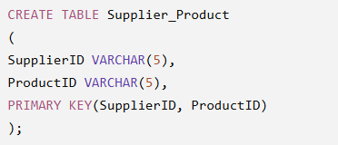

Supplier_Project
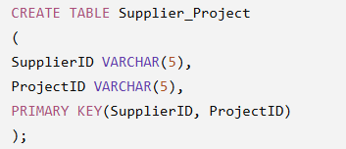

Product_Project
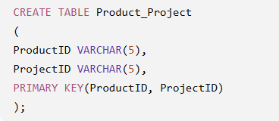

9. Advantages of 5NF
- Eliminates join dependency redundancy.
- Prevents update anomalies.
- Improves data consistency.
- Supports complex database designs.
- Reduces duplicate information.
- Enables efficient data maintenance.

10. Applications
- Supply Chain Management
- Manufacturing Systems
- ERP Systems
- Airline Reservation
- Hospital Management
- University Databases

11. Difference Between 4NF and 5NF
4NF | 5NF
Removes Multi-Valued Dependencies | Removes Join Dependencies
Uses decomposition based on MVD | Uses decomposition based on JD
Reduces redundancy due to MVD | Reduces redundancy due to JD

Q10. A System Uses Inefficient SQL Queries for Data Retrieval. Analyze the Queries and Optimize Them Using Joins, Indexing Concepts, or Query Restructuring.

1. Introduction
SQL query optimization is the process of improving the efficiency and performance of SQL statements. Poorly written queries increase execution time, consume more memory, and reduce database performance. Optimization techniques such as JOINs, indexes, and query restructuring help retrieve data faster.

2. Definition of Query Optimization
Query Optimization is the process of rewriting SQL queries and using database techniques to execute them with minimum cost and maximum efficiency.

3. Causes of Inefficient Queries
- Using SELECT *.
- Missing indexes.
- Unnecessary subqueries.
- Redundant conditions.
- Improper JOINs.
- Functions in the WHERE clause.
- Retrieving unnecessary data.

4. Example of an Inefficient Query
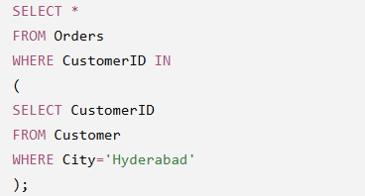

5. Optimized Query Using JOIN
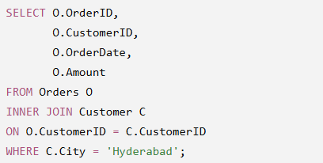

6. Using Indexes
Create an Index
CREATE INDEX idx_customer
ON Customer(CustomerID);
Another Index
CREATE INDEX idx_city
ON Customer(City);
Benefits
- Faster searching.
- Faster sorting.
- Improved JOIN performance.
- Reduced query execution time.

7. Query Restructuring
Inefficient Query
SELECT *
FROM Employee
WHERE Salary > 30000
AND Salary > 20000;
Optimized Query
SELECT EmployeeID,
EmployeeName,
Salary
FROM Employee
WHERE Salary > 30000;

8. Other Optimization Techniques
- Retrieve only required columns.
- Use INNER JOIN instead of unnecessary subqueries.
- Create indexes on frequently searched columns.
- Avoid redundant conditions.
- Use EXISTS instead of IN for large datasets when appropriate.
- Limit result sets using LIMIT or TOP.
- Analyze execution plans.

9. Advantages of Query Optimization
- Faster execution.
- Better CPU utilization.
- Lower memory consumption.
- Improved database performance.
- Efficient resource usage.
- Better user experience.

10. Applications
- Banking Systems
- Online Shopping
- Hospital Management
- University Databases
- Inventory Systems
- Railway Reservation
- Financial Applications

11. Best Practices
- Use meaningful indexes.
- Avoid SELECT *.
- Normalize the database.
- Use proper JOIN conditions.
- Optimize subqueries.
- Keep statistics updated.
- Monitor slow queries regularly.

13. Conclusion
Optimizing SQL queries significantly improves database performance by reducing execution time and resource consumption. Techniques such as efficient JOINs, proper indexing, query restructuring, and selective data retrieval help build scalable and high-performing database systems. These practices are essential for handling large datasets in modern applications such as banking, e-commerce, healthcare, and enterprise resource planning (ERP) systems.

